ONEWAY SA BY Age
/STATISTICS DESCRIPTIVES HOMOGENEITY WELCH
/PLOT MEANS
/MISSING ANALYSIS.

Oneway

Notes
Output Created |  | 05-May-2019 23:16:49
Comments
Input | Active Dataset | DataSet0
Input | Filter | <none>
Input | Weight | <none>
Input | Split File | <none>
Input | N of Rows in Working Data File | 30
Missing Value Handling | Definition of Missing | User-defined missing values are treated as missing.
Missing Value Handling | Cases Used | Statistics for each analysis are based on cases with no missing data for any variable in the analysis.
Syntax |  | ONEWAY SA BY Age  /STATISTICS DESCRIPTIVES HOMOGENEITY WELCH  /PLOT MEANS  /MISSING ANALYSIS.
Resources | Processor Time | 00 00:00:00.188
Resources | Elapsed Time | 00 00:00:00.181

[DataSet0]

Descriptives
 | N | Mean | Std. Deviation | Std. Error | 95% Confidence Interval for Mean
 |  |  |  |  | Lower Bound | Upper Bound
18 | 1 | 14.0000 | . | . | . | .
19 | 2 | 48.5000 | 16.26346 | 11.50000 | -97.6214 | 194.6214
20 | 2 | 19.5000 | .70711 | .50000 | 13.1469 | 25.8531
21 | 2 | 20.5000 | 3.53553 | 2.50000 | -11.2655 | 52.2655
22 | 9 | 18.6667 | 13.67479 | 4.55826 | 8.1553 | 29.1780
23 | 1 | 24.0000 | . | . | . | .
24 | 1 | 22.0000 | . | . | . | .
25 | 1 | 15.0000 | . | . | . | .
28 | 2 | 43.5000 | 33.23402 | 23.50000 | -255.0958 | 342.0958
30 | 1 | 15.0000 | . | . | . | .
41 | 1 | 33.0000 | . | . | . | .
43 | 1 | 35.0000 | . | . | . | .
48 | 3 | 21.6667 | 6.50641 | 3.75648 | 5.5039 | 37.8295
52 | 1 | 23.0000 | . | . | . | .
56 | 1 | 62.0000 | . | . | . | .
58 | 1 | 58.0000 | . | . | . | .
Total | 30 | 26.6000 | 16.74062 | 3.05640 | 20.3490 | 32.8510

Descriptives
 | Minimum | Maximum
18 | 14.00 | 14.00
19 | 37.00 | 60.00
20 | 19.00 | 20.00
21 | 18.00 | 23.00
22 | 5.00 | 50.00
23 | 24.00 | 24.00
24 | 22.00 | 22.00
25 | 15.00 | 15.00
28 | 20.00 | 67.00
30 | 15.00 | 15.00
41 | 33.00 | 33.00
43 | 35.00 | 35.00
48 | 15.00 | 28.00
52 | 23.00 | 23.00
56 | 62.00 | 62.00
58 | 58.00 | 58.00
Total | 5.00 | 67.00

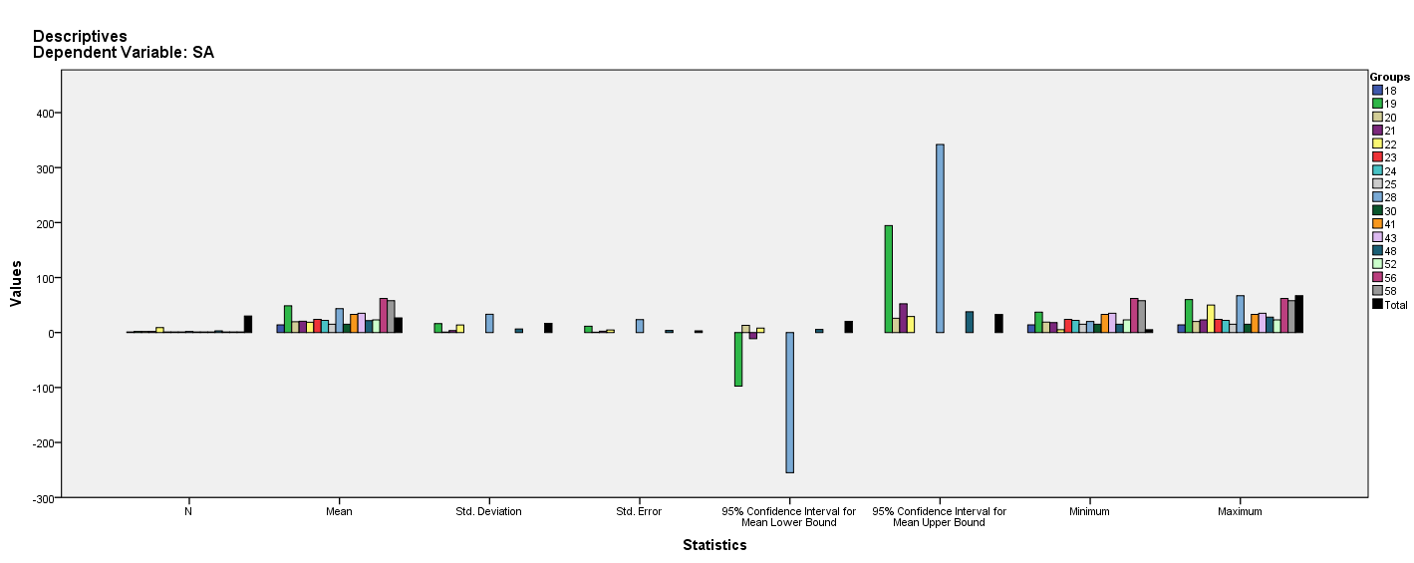

Test of Homogeneity of Variances
SA
Levene Statistic | df1 | df2 | Sig.
2.650ª | 5 | 14 | .069
a. Groups with only one case are ignored in computing the test of homogeneity of variance for SA.

ANOVA
SA
 | Sum of Squares | df | Mean Square | F | Sig.
Between Groups | 5164.533 | 15 | 344.302 | 1.627 | .185
Within Groups | 2962.667 | 14 | 211.619
Total | 8127.200 | 29

Robust Tests of Equality of Means^{b}
SA
 | Statisticª | df1 | df2 | Sig.
Welch | . | . | . | .
a. Asymptotically F distributed.
b. Robust tests of equality of means cannot be performed for SA because at least one group has the sum of case weights less than or equal to 1.

Means Plots

